Abdul zishan 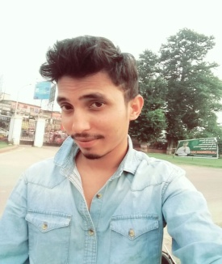
Email Id: zishantheprince69@gmail.com
Contact No: 96583355832

Objective
Looking forward to an opportunity for working in a dynamic, challenging environment, where I can utilize my skills for developing my career and for the growth of the organization.

Academic Qualification
Qualification | Name of Institutes | University/ Board | Year | Aggregate
BSc.(IST) | Ravenshaw University | Ravenshaw University | 2016 | 61%
H.S.E | Hi tech science college | C.H.S.E. Odisha | 2013 | 49.9%
I.C.S.E | St joseph;s school | I.C.S.E, Odisha | 2011 | 59.9%
Persuing P.G | Utkal university | Utkal university

Technical Qualification
- Operating System: Windows
- Database: SQL Server
- Languages: C.JAVA,.Net
- Web Technology: HTML, ASP.Net

Academic Project
Project name: Alumini Management System

Front-End: Java, JSP, Servlets, JavaScript

Back-End: My SQL

Team Size: 8

Duration: 6 months

Description: This is a web application which helps in communicating between aluminies and the

current students for better suggestion and for deciding better career growth. This web application can run

worldwide and can be accessed over internet using web browsers.

Personal Strengths
- Positive Thinking
- Open to any challenging work
- Good learner by observation
- Good communication skills

Extra-Curricular Activities and Hobbies
- Participated in national level adventure camp shimla.
- Participated in different blood donation camp and have good idea upon event management.
- Interested in playing cricket and foothball.

Personal Details
Father’s Name: Mr. mir abdul faruck
Date of Birth: 08th febuary 1995
Sex: male
Religion: mushlim
Language Known: Oriya, Hindi, English.
Marital Status: Unmarried
Hobbies: Photography & travelling.

I hereby certify that the information given in my Curriculum Vitae is correct and complete to the best of my knowledge.

Name: Abdul zishan

